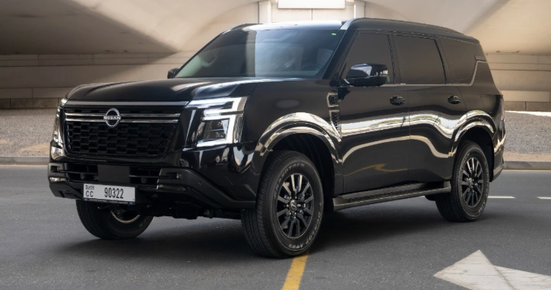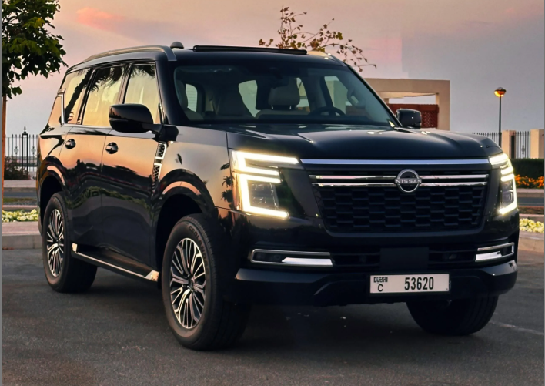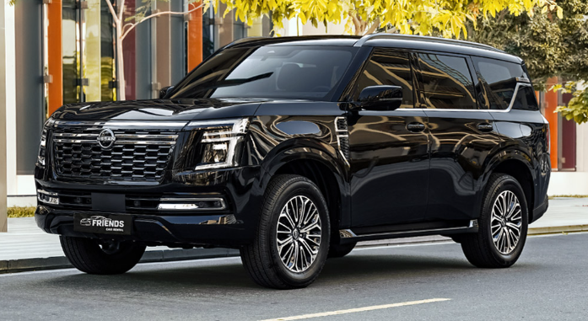

**Main Specifications** of the **2025 Nissan Patrol**

**🚗 Powertrains & Performance**

| **Engine** | **Power** | **Torque** | **Transmission** | **Drive** |
| --- | --- | --- | --- | --- |
| **3.8 L V6 NA** | ~316 hp | 386 Nm | 9‑speed auto | Full-time 4WD |
| **3.5 L Twin‑Turbo V6 (VR35DDTT)** | ~425 hp | 700 Nm | 9‑speed auto | Full-time 4WD |

Fuel economy is rated at ~9.7 km/L for the 3.8 L and ~10.1 km/L for the twin-turbo. The **97 L fuel tank** provides solid range

**📏 Dimensions & Capacities**

* **Length × Width × Height**: ~5,205 × 1,995 × 1,940 mm
* **Wheelbase**: 3,075 mm
* **Ground clearance**: ~244–253 mm
* **Curb weight**: ~2,700–2,830 kg
* **Seating** for **7–8 passengers**, with generous legroom and versatile cabin configurations .

Boot capacity is significantly increased (about 30% more than Y62 model)

**🛠️ Chassis & Off-road**

* **Full-time 4WD** with selectable drive modes: Sport, Eco, Sand, Mud, Rock
* **Suspension**: Adaptive air suspension with electronically controlled dampers
* **Brakes**: Ventilated discs front & rear; ABS/EBD standard
* **Wheels/Tires**: Typically 18″ alloy with 265/70 R18 tires

**🛋️ Interior & Technology**

* **Monolithic 28.6″ display** combining dual 14.3″ digital gauges + infotainment
* **Rear entertainment**: Dual 12.8″ screens; Klipsch premium audio (12 speakers)
* **Luxury**: Quilted “Zero Gravity” leather seats with heating/cooling and optional massage; panoramic sunroof; 64‑colour ambient lighting
* **Convenience**: Google-built infotainment, wireless CarPlay/Android Auto, ProPILOT Assist, powerfold 3rd-row, rotary gear selector, power tailgate

**⛽ Fuel & Efficiency**

* **3.8 L**: ~9.7 km/L (~10.3 L/100km)
* **3.5 L TT**: ~10.1 km/L (~9.9 L/100km)
* **Fuel Tank**: 97 L

Real-world feedback indicates **4.5–7 km/L** depending on driving conditions

**✅ Summary**

The 2025 Nissan Patrol offers:

* **Two strong V6 engines**: efficient NA 3.8 L or powerful TT 3.5 L
* **Robust 4WD, adjustable suspension, and off-road focus**
* **Spacious, luxurious interior with cutting-edge tech and entertainment systems**
* **Fuel economy ranging from ~9.7 to 10 km/L**, with trade-offs depending on usag